<https://medium.com/@gabrieltseng/clustering-and-collaborative-filtering-visualizing-clusters-using-t-sne-f9718e7491e6>

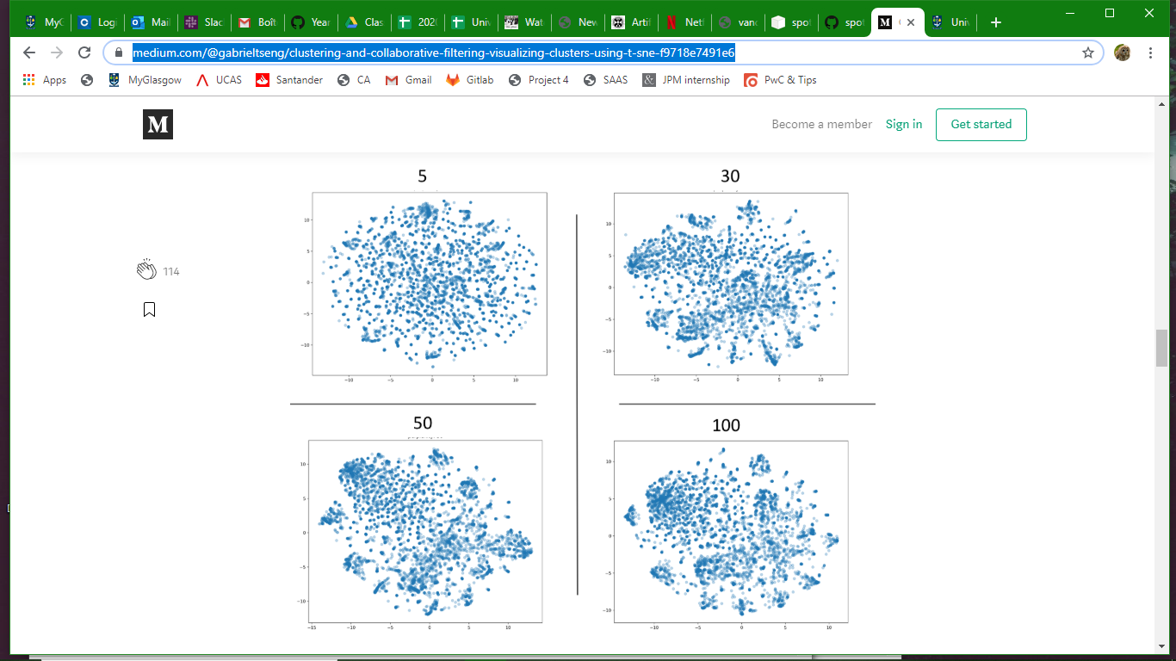

“The perplexity can be interpreted as a smooth measure of the effective number of neighbours. The performance of SNE is fairly robust to changes in the perplexity, and typical values are between 5 and 50.” <http://www.jmlr.org/papers/volume9/vandermaaten08a/vandermaaten08a.pdf>

|  |  |
| --- | --- |
| Perplexity = 5 | Perplexity = 30 |
| Perplexity = 50 | Perplexity = 100 |

Perplexity = 20.0 (Model iterations : 500, tSNE : 1500)

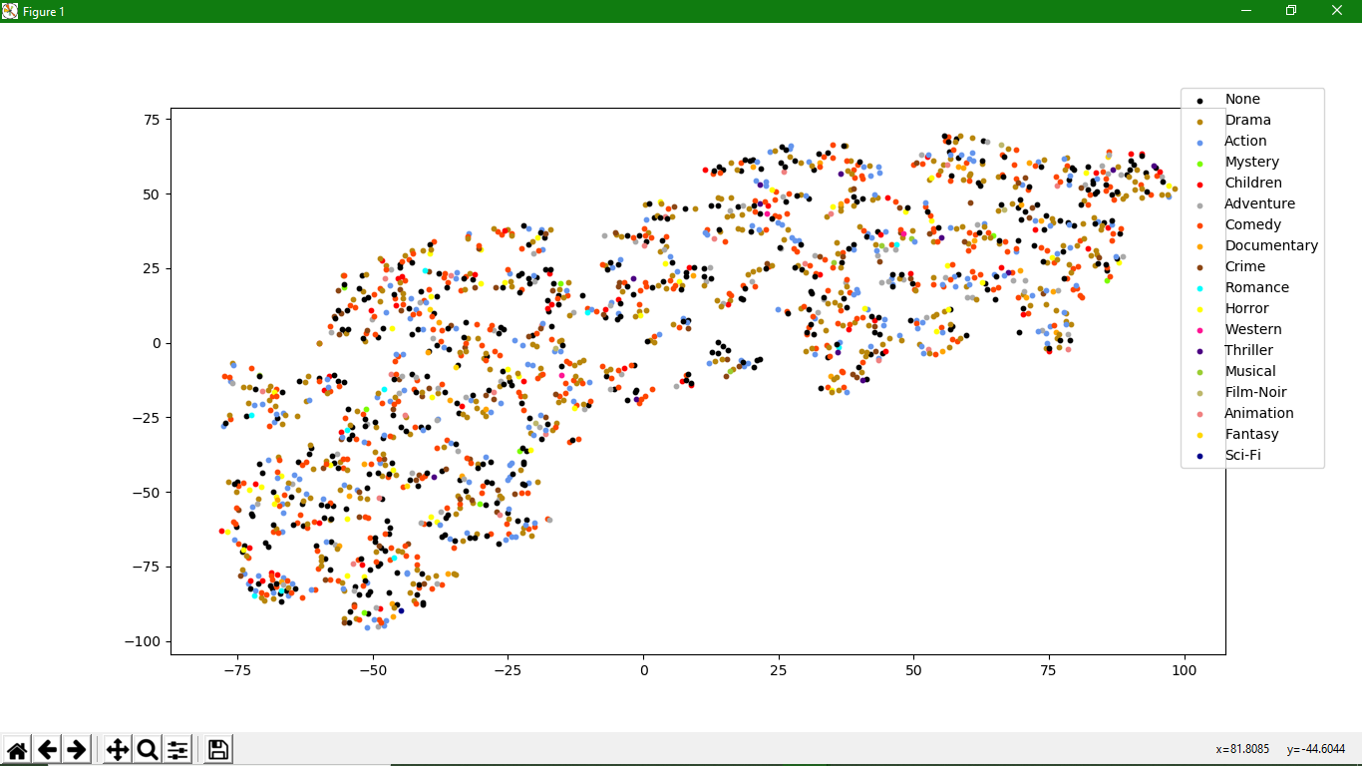

Perplexity = 5.0 (Model iterations : 500, tSNE : 1500)

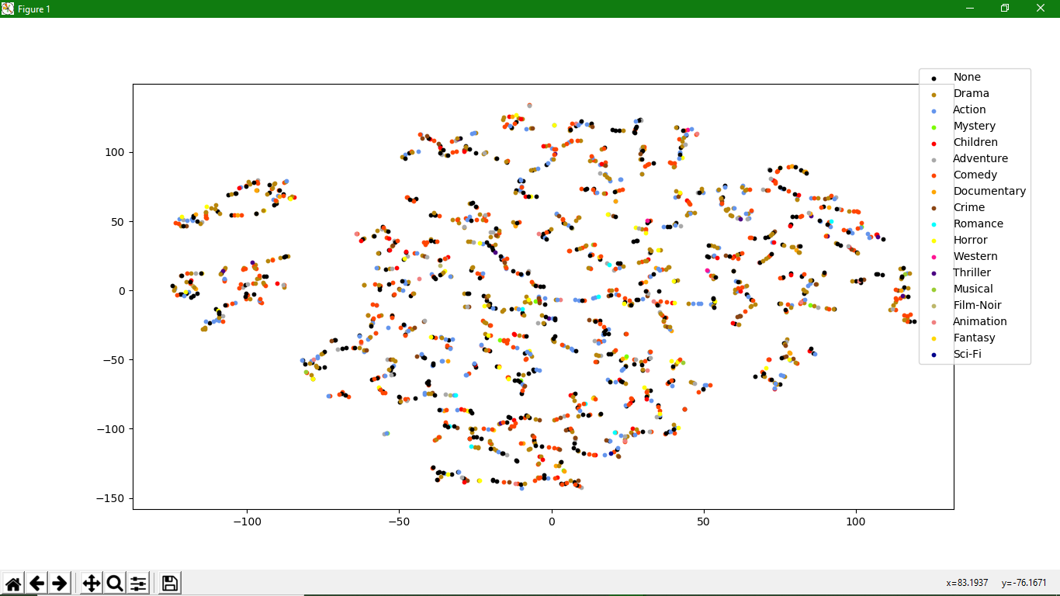

Perplexity = 5.0 (Model iterations : 300, tSNE : 1500)

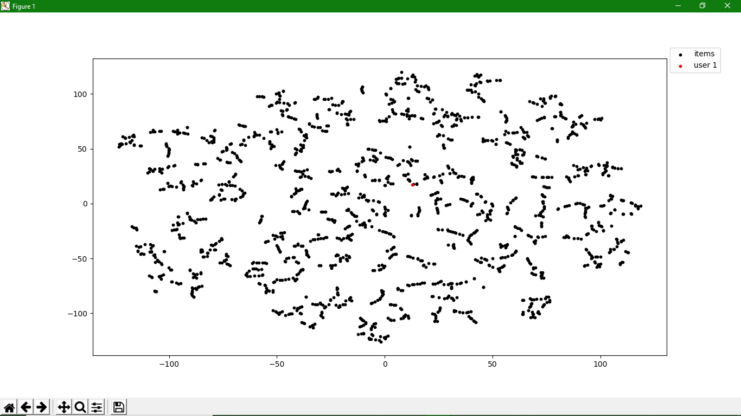

Perplexity = 30.0 (Model iterations : 300, tSNE : 1500)

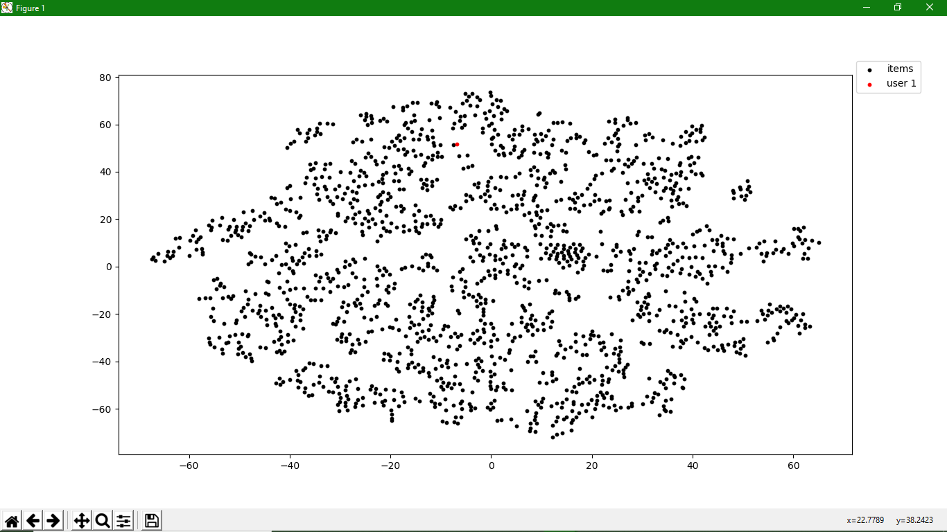

Single-User representation with annotations: Example

